1. Title of the Project: **HAND CRICKET GAME**

2. Details :

1. Abhilash Tyagi

3. Abstract of the project

A simple yet an amazing game to play with your friends and family. Playing cricket is fun, but what if you don't have the equipment? What if you want to play a sweet little game in any given moment?

The aim is to make the game playable on computer with the Computer vs Human mode. The game will start from a toss “ODD OR EVEN”. Now, the player will throw(input) a number. After this the computer will show its throw based on any random number. If the sum of these numbers is even then the player choosing even will be winner of the toss and same goes for the odd. The winning party will choose either to bat or to bowl. After this, the game will continue as per the choice filled. The batsman will now keep on inputting the runs against the balls delivered by the bowler. When both the players will throw a same number, it will be declared as an “OUT.” Now, the other player, yet to bat, will start his/her batting and will continue till he/she is out or surpasses the score given by first player. At the end, the winner will be declared and the game will be over.

Specialty: The program includes Artificial Intelligence enabled with the help of arrays which record the throw of last 6 balls(1 over) and tries to find a pattern in these throws. If the computer finds any specific pattern in these throws, it follows the series or pattern and throw its ball accordingly, similar to what a human being will do in real life.

4. Topics of SDF-I used

1. Strings
2. Arrays
3. Functions
4. File Handling
5. Loops

5. Design of the project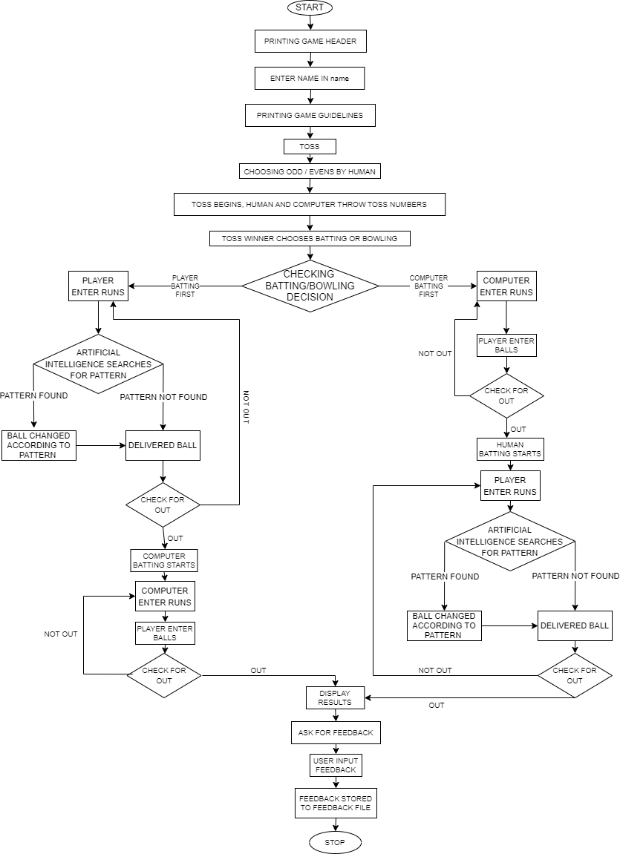

1. Implementation Details

Our program starts with printing few lines of game header and then it asks user to enter his/her name and stores it in name variable. After this, it prints the guidelines/rules of the game. Now, it asks user to type “START” to start the game after reading the guidelines.

Now, there is a toss. For the toss a function tossTime() is called. The user is allowed to enter his/her choice of odd/even every time. After the choice is recorded game moves further and asks for the toss number from the user and as the user input the valid input computer prints its toss number based on any random number between 1-6 using the rand(); function. The compiler do the sum of both the toss numbers and then print the toss result (who is the winner). If computer is the winner the compiler itself chooses Batting/Bowling else it gives the choice to user. This choice is recorded in decision variable.

Now the compiler returns to the main function. The main function according to the decision variable checks whether whose batting is first- compiler or human. If computer’s batting is n first innings then compiler calls computerBattingFirst() function else it calls playerBattingFirst() function. computerBattingFirst() functions in the first innings allows user to enter the ball and computer the runs whereas the playerBattingFirst () function allows user to enter the runs first and then the balls in the 2nd innings. At every ball if it is a not out then the runs are added in the final score. Every time the player/human bats the compiler through its Artificial Intelligence stores its previous run input in an array and checks for pattern, if it finds any specific pattern it manipulates the ball by computer, thus increasing the chances of OUT.

Our AI is efficient in recognizing the following patterns

A,A, A

A,A+1, A+2

A,A-1, A-2

A,A+2, A+4

A,A-2, A-4

A,B,A,B, A

A,B,C,A,B,C, A

After any of these function return to main function, the compiler calls the results() function to declare the results on the screen based on the scores stored by the Batting functions.

After results() function the compiler calls upon feedbackTime() function to record human’s rating for our game. This rating is stored in a .txt file by the name of the user every time.

7. References

* **Course Lecture Slides** for the topics like Strings, Functions, File Handling, Arrays, I/O, loops.
* In order to generate a random number between 1-6 for batting/bowling by computer, we have to gather knowledge of **rand(); function**. We gathered it from **GeekforGeeks** and **CodeWithHarry** (YouTube Channel).

SOURCE CODE

#include <stdio.h>

#include <stdlib.h>

#include <string.h>

/*variables for toss

comp_toss : to store computer toss number

human toss : to store human toss number

toss_total : to store sum of toss numbers

name : to store name of user

game_starter : to store start string to continue program

toss : to store even/odd choice

decision : to store decision of batting/bowling

*/

int comp_toss=0,human_toss=0,toss_total=0;

char name[50],game_starter[10],toss[5],decision[10];

/*variables for innings

comp_ball : to store ball by computer

human_run : to store runs by human player

human_score : to store total human runs

comp_run : to store run by computer

human_ball : to store ball by human player

comp_score : to store runs by computer

*/

int comp_ball=0,human_run=0,human_score=0,comp_run=0,human_ball=0,comp_score=0;

/*variables for Artificial intelligence

no : to store no. of balls delivered

intelligence : array to store player's run of past balls

*/

int no=0,i;

int intelligence[50];

void tossTime()

{

comp_toss=rand()%6+1;// computer genrates its toss by rand() function

printf("\n<<<-----TOSS----->>>\n\n");

printf("ODDS OR EVENS: ");//user will enter toss choice

gets(toss);

printf("\nThrow Toss: ");//user will enter toss number

scanf("%d",&human_toss);

while(human_toss>6||human_toss<1)// re enter toss number if it exeeds limit 1-6

{

printf("You Must Enter The Numbers From 1-6\n");

printf("Throw Toss: ");

scanf("%d",&human_toss);

}

printf("Computer's Toss: %d\n",comp_toss);//computer prints its toss number

toss_total=human_toss+comp_toss;//sum of toss

printf("\nToss Total = %d\n",toss_total);

if(strcmp(toss,"EVENS")==0||strcmp(toss,"EVEN")==0)

{

if(toss_total%2==0)

{

printf("\nIt's an even number\n");

printf("Yeahh!, You Won The Toss\n");

printf("\nChoose Batting or Bowling: ");

scanf("%s",decision);

}

else

{

printf("\nIt's an odd number\n");

if( (rand()%6+1) %2==0)

{

strcpy(decision,"cBATTING");

printf("Ohhh! You Lost The Toss\n");

printf("COMPUTER CHOOSES BATTING\n\n");

}

else

{

strcpy(decision,"cBOWLING");

printf("Ohhh! You Lost The Toss\n");

printf("COMPUTER CHOOSES BOWLING\n\n");

}

}

}

else

{

if(toss_total%2==0)

{

printf("It's an even number\n");

if( (rand()%6+1) %2==0)

{

strcpy(decision,"cBATTING");

printf("Ohhh! You Lost The Toss\n");

printf("COMPUTER CHOOSES BATTING\n\n");

}

else

{

strcpy(decision,"cBOWLING");

printf("Ohhh! You Lost The Toss\n");

printf("COMPUTER CHOOSES BOWLING\n\n");

}

}

else

{

printf("It's an odd number\n");

printf("Yeahh!, You Won The Toss\n");

printf("\nChoose Batting or Bowling: ");

scanf("%s",decision);

}

}

printf("\n");

}

void playerBattingFirst()

{

do

{

comp_ball=rand()%6+1;

printf("Player's Run: ");

scanf("%d",&human_run);

while(human_run>6||human_run<1)

{

printf("You Must Enter The Numbers From '1' To '6' \n");

printf("Player's Run: ");

scanf("%d",&human_run);

}

intelligence[++no]=human_run;

if(no>2)

{

if(intelligence[no-1]==intelligence[no-2])

comp_ball=intelligence[no-1];

if((intelligence[no-1]-intelligence[no-2])==1)

comp_ball=intelligence[no-1]+1;

if(comp_ball>6)

comp_ball-=6;

if((intelligence[no-1]-intelligence[no-2])==-1)

comp_ball=intelligence[no-1]-1;

if(comp_ball<1)

comp_ball+=6;

if((intelligence[no-1]-intelligence[no-2])==2)

comp_ball=intelligence[no-1]+2;

if(comp_ball>6)

comp_ball-=6;

if((intelligence[no-1]-intelligence[no-2])==-2)

comp_ball=intelligence[no-1]-2;

if(comp_ball<1)

comp_ball+=6;

}

if(no>4)

{

if(intelligence[no-1]==intelligence[no-3]&&intelligence[no-2]==intelligence[no-4])

comp_ball=intelligence[no-2];

}

printf("Computer's Ball: %d\n",comp_ball);

if(comp_ball==human_run)

{

printf("\nOUT!!!!!\n");

printf("NOW , ITS COMPUTER'S TURN TO BAT\n");

printf("Target for Computer - %d Run/Runs\n\n",(human_score+1));

do

{

comp_run=rand()%6+1;

printf("Player's Ball: ");

scanf("%d",&human_ball);

while(human_ball>6||human_ball<1)

{

printf("You Must Enter The Numbers From '1' To '6' \n");

printf("Player's Ball: ");

scanf("%d",&human_ball);

}

printf("Computer's Run: %d\n",comp_run);

if(human_ball==comp_run)

{

printf("\nOUT!!!!!\n");

break;

}

else

comp_score+=comp_run;

if(comp_score>human_score)

break;

} while(comp_run!=human_ball);

break;

}

else

human_score+=human_run;

} while(human_run!=comp_ball);

}

void computerBattingFirst()

{

do

{

comp_run=rand()%6+1;

printf("Player's Ball: ");

scanf("%d",&human_ball);

while(human_ball>6||human_ball<1)

{

printf("You Must Enter The Numbers From '1' To '6' \n");

printf("Player's Ball: ");

scanf("%d",&human_ball);

}

printf("Computer's Run: %d\n",comp_run);

if(human_ball==comp_run)

{

printf("\nOUT!!!!!\n");

printf("NOW, ITS COMPUTER'S CHANCE TO BOWL\n");

printf("Target for You - %d Run/Runs\n\n",(comp_score+1));

do

{

comp_ball=rand()%6+1;

printf("Player's Run: ");

scanf("%d",&human_run);

while(human_run>6||human_run<1)

{

printf("You Must Enter The Numbers From '1' To '6' \n");

printf("Player's Run: ");

scanf("%d",&human_run);

}

intelligence[++no]=human_run;

if(no>2)

{

if(intelligence[no-1]==intelligence[no-2])

comp_ball=intelligence[no-1];

if((intelligence[no-1]-intelligence[no-2])==1)

comp_ball=intelligence[no-1]+1;

if(comp_ball>6)

comp_ball-=6;

if((intelligence[no-1]-intelligence[no-2])==-1)

comp_ball=intelligence[no-1]-1;

if(comp_ball<1)

comp_ball+=6;

if((intelligence[no-1]-intelligence[no-2])==2)

comp_ball=intelligence[no-1]+2;

if(comp_ball>6)

comp_ball-=6;

if((intelligence[no-1]-intelligence[no-2])==-2)

comp_ball=intelligence[no-1]-2;

if(comp_ball<1)

comp_ball+=6;

}

if(no>4)

{

if(intelligence[no-1]==intelligence[no-3]&&intelligence[no-2]==intelligence[no-4])

comp_ball=intelligence[no-2];

}

printf("Computer's Ball: %d\n",comp_ball);

if(comp_ball==human_run)

{

printf("\nOUT!!!!!\n");

break;

}

else

human_score+=human_run;

if(human_score>comp_score)

break;

}while(comp_ball!=human_run);

}

else

comp_score+=comp_run;

} while(comp_run!=human_ball);

}

void results()

{

printf("\nComputer's Score: %d\n",comp_score);

printf("Your Score: %d\n",human_score);

printf("\n");

if(human_score<comp_score)

{

printf(" COMPUTER WINS\n");

printf(" Better Luck Next Time\n");

printf(" |====||====| Thanks For Playing |====||====|\n");

}

else

if(human_score>comp_score)

{

printf(" Congrats, YOU WIN\n");

printf(" |====||====| Thanks For Playing |====||====|\n");

}

else

{

printf(" THERE IS A TIE\n");

printf(" |====||====| Thanks For Playing |====||====|\n");

}

printf("{{ {{ {{ <<<< HOPE , YOU LIKED THE GAME >>>> }} }} }}\n");

printf("\n\nThe Game was developed by:\n\n");

printf("Kush Agarwal\n");

printf("NBTG14987\n\n");

printf("Abhilash Tyagi\n");

printf("NBTG13867\n\n");

}

void ratingTime()

{

int rating;

FILE *feedback;

feedback=fopen("Feedback.txt", "a");

printf("How much would you like to rate us out of 5?\nEnter Rating: ");

scanf("%d",&rating);

while(rating>5||rating<1)

{

printf("You Must Enter The Rating From 1-5\n");

printf("Enter Rating: ");

scanf("%d",&rating);

}

fprintf(feedback, "%s rated us %d/5.\n", name, rating);

}

int main()

{

printf("\n");

printf(" MINI PROJECT\n");

printf(" SDF LAB\n\n");

printf(" WELCOME TO THE GAME\n");

printf(" ------+++ DIGITAL HAND CRICKET +++------ \n");

printf("\n");

printf("Enter Your Name To Move Ahead\n");

gets(name);

printf("Here are some guidelines to play this game.\n");

printf("First, there will be a toss between the COMPUTER and PLAYER i.e. you\n");

printf("You will enter a choice of even or odd and throw your toss number between 1-6, COMPUTER will do the same\n");

printf("If the sum of both the toss numbers is even, then the player chosing even will win the toss, and vice-versa\n");

printf("The winner of the toss will get a chance to choose BATTING or BOWLING\n");

printf("The Game Will Than Start According To The Choice Proceeded\n");

printf("Everytime, The User Will Put The Ball Or Bat Before The System\n");

printf("Everytime the System gives you the Message \"Player's Run\", You will enter Your Number - the run.\n");

printf("Everytime the System gives you the Message \"Player's Ball\", You will enter Your Number - the ball.\n");

printf("You Must Enter The Numbers From '1' To '6' and in the Same Limits the Computer Will Play\n");

printf("At The End Of First Innings, The Target Will be Displayed\n");

printf("After the second innings, The Winner Will Be Decided On The Basis Of The Final Scores of both the players\n");

printf("\n");

printf("Now , Type \"START\" To Start The Game\n");

gets(game_starter);

tossTime();

if(strcmp(decision,"BATTING")==0||strcmp(decision,"cBOWLING")==0)

{

playerBattingFirst();

}

else

{

computerBattingFirst();

}

results();

ratingTime();

return 0;

}